# Media Analysis - ChatGPT_ AI grows more powerful as we become more predictable _ Arab News

## Short Summary

The article is about the rapid adoption of ChatGPT, highlighting its impressive user growth as a sign of increasing human predictability due to internet use, while noting its current limitations in reasoning compared to human intelligence, alongside ethical concerns regarding AI development and emphasizing the need for thoughtful integration into society.

## Summary

- ChatGPT's adoption rate is unprecedented, reaching a million users within five days, highlighting a rapid embrace similar to other groundbreaking technologies.  
   
- Despite the excitement around AI-powered tools like ChatGPT, they lack the human mind's ability to reason and think deeply, relying instead on large datasets for content generation.  
  
- The increasing predictability of human behavior, influenced by decades of internet and smartphone use, enhances AI effectiveness but raises ethical concerns about reinforcing ideologies without critical reflection.  
  
- The future success of AI tools lies in collaboration with humans rather than complete replacement, urging companies and governments to consider gradual integration while reflecting on the implications for human intelligence.

## Question 1

The text frames the public discussion about ChatGPT by emphasizing its rapid adoption and transformative potential while also highlighting its current limitations. Several metaphors are used to frame this narrative:  
  
1. **AI Age**: The release of ChatGPT is described as signaling "the proper start of the AI age," suggesting a new era marked by significant technological change.  
  
2. **Upside-Down World**: It mentions that the world has been "turned upside down," indicating how disruptive and transformative AI tools like ChatGPT are perceived to be.  
  
3. **Infancy of Technology**: Platforms like ChatGPT are described as being in their "infancy," highlighting that while they are powerful, they are still immature compared to human intelligence.  
  
4. **Predictability vs. Reasoning**: The discussion revolves around how AI leverages predictability from data trends, contrasting it with the human ability for reasoning and creativity. This highlights a metaphorical boundary between machine capabilities and human cognition.  
  
5. **Superficial Predictions**: AI predictions are described as "superficial and dubious," underscoring a perceived lack of depth in current AI understanding compared to nuanced human thought.  
  
6. **Ethics and Control**: There is an implication that AI systems could "lock in" ideologies, framing them metaphorically as potentially rigid or uncontrollable forces if not managed ethically.  
  
These metaphors collectively shape the discourse around ChatGPT by balancing its potential with cautionary notes about its limitations and ethical implications.

## Question 2

### Widely Covered Aspects:  
  
1. **Rapid Adoption**: The text highlights ChatGPT's unprecedented adoption rate, with a million unique users within five days of release.  
   
2. **Impact on Work**: Discussions focus on the implications for the future of work in an AI-powered world and how it may transform job roles.  
  
3. **Predictability vs. Reasoning**: There is significant coverage on human predictability due to internet and smartphone usage, contrasting this with AI's current lack of true reasoning capabilities.  
  
4. **Ethical Concerns**: The text delves into ethical issues surrounding AI development, such as the potential reinforcement of ideologies and Microsoft’s dismissal of its ethics team.  
  
5. **Human-AI Collaboration**: Emphasized is the importance of collaboration between humans and AI tools rather than full replacement or outsourcing.  
  
### Ignored Aspects:  
  
1. **Technical Limitations**: While there are mentions of limitations in reasoning, detailed technical challenges specific to developing more advanced AI systems aren't deeply explored.  
  
2. **Economic Impact**: The broader economic effects of widespread AI adoption on industries and global markets receive little attention.  
  
3. **Privacy Concerns**: Issues related to data privacy and how user information is managed by AI platforms are not addressed.  
  
4. **Regulatory Frameworks**: There's no discussion about the existing or potential regulatory frameworks governing AI deployment and use.  
  
5. **Long-term Societal Changes**: Beyond work, the long-term societal changes prompted by AI technologies are not thoroughly examined.  
  
By focusing on these covered aspects while overlooking others, the narrative shapes a specific understanding of AI's role in contemporary society.

## Question 3

The text does not mention any specific role or involvement of the Arabic World in relation to AI or how they might be leveraging it. Therefore, the answer is "Not mentioned."

## Question 4

The final message of the article emphasizes that while AI tools like ChatGPT show impressive capabilities due to increased predictability from internet usage, they lack fundamental reasoning abilities. The author argues for a balanced integration of these technologies in society, stressing collaboration rather than complete reliance on AI. Ethical considerations and human intelligence should guide AI development to prevent potential misuse or over-reliance. This cautious approach allows us to reflect on the impact of technology on human work and thought processes.

## Sentiment

The sentiment is 2.0

## Entities

ChatGPT-4 https cdn.openai.com, Googles, Arab News, stu, Exponential View, OpenAI, TikTok, Twitter ibnezra https twitter.com, Noam Chomsky, Chomsky, The New York Times Whereas, iPhone, AI, ibnezra lang, Copyright Syndication Bureau, Joseph Dana, Gmail, JOSEPH DANA

## Highlights

#fb5b89#69aff0#7cc867#f9cd59

## Wordcloud for #fb5b89 Highlights

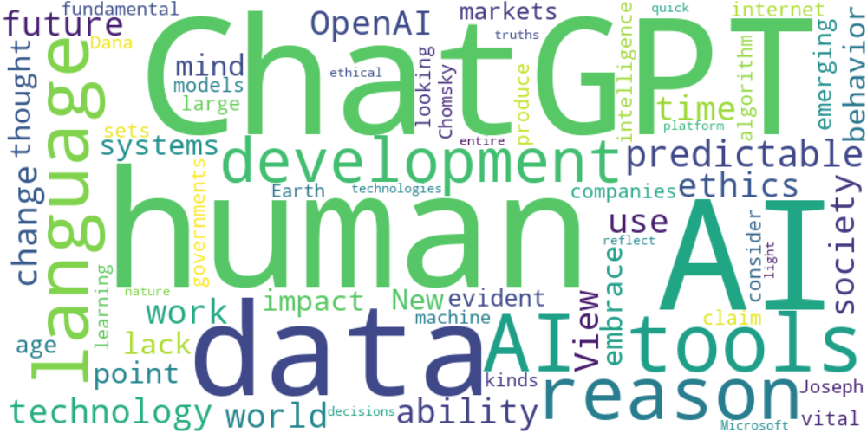

Top 10 words:

- AI: 14

- ChatGPT: 10

- human: 8

- tools: 7

- data: 6

- reason: 5

- language: 5

- predictable: 5

- future: 4

- work: 4

## Wordcloud for #69aff0 Highlights

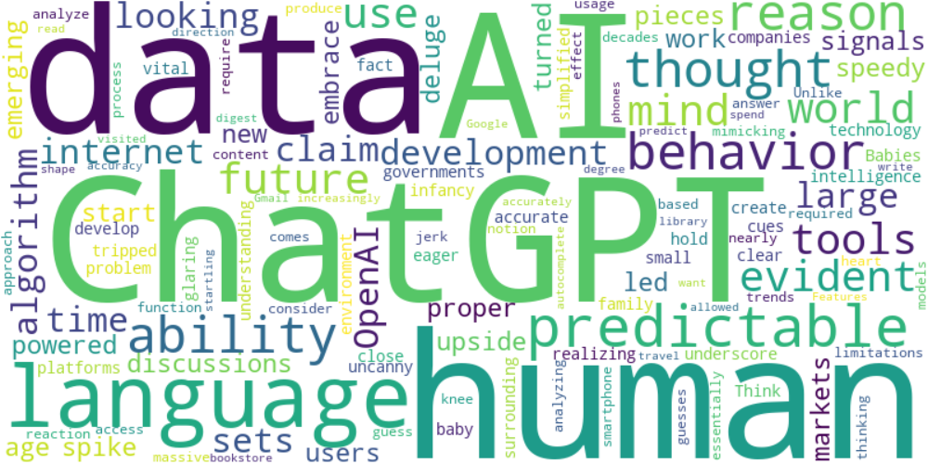

Top 10 words:

- AI: 6

- ChatGPT: 6

- data: 6

- human: 5

- language: 5

- predictable: 4

- reason: 3

- ability: 3

- behavior: 3

- thought: 2

## Wordcloud for #7cc867 Highlights

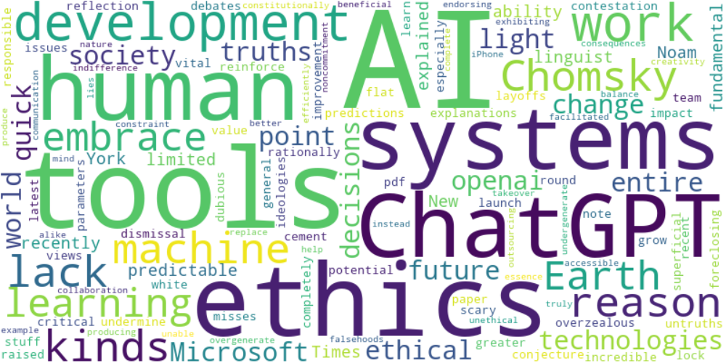

Top 10 words:

- AI: 7

- tools: 5

- ethics: 4

- systems: 3

- ChatGPT: 3

- work: 3

- lack: 2

- reason: 2

- Chomsky: 2

- kinds: 2

## Wordcloud for #f9cd59 Highlights

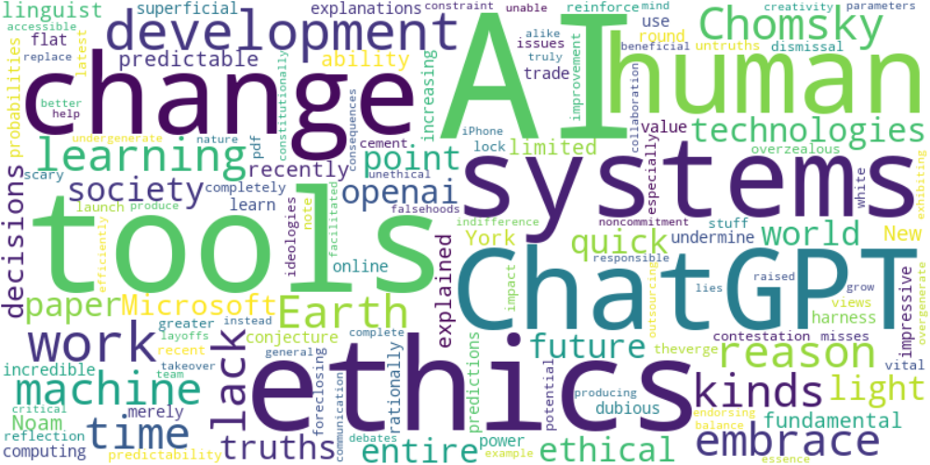

Top 10 words:

- AI: 7

- tools: 5

- ethics: 4

- systems: 3

- change: 3

- ChatGPT: 3

- work: 3

- lack: 2

- reason: 2

- Chomsky: 2